Newsletter Date January 23, 2014
Volume 2, Issue 1
Speech Room News

How Was School Today?

If your child typically answers this question with one-word answers, such as “good” or “okay”, you are not alone. Some ways to encourage your student to volunteer more information about his/her school day is to ask more specific or open-ended questions. An open-ended question is one that allows the child to respond in a variety of ways, providing opportunities to use rich language (e.g., Instead of asking, “What book did you read?” you could ask, “What was the best part of the story?” Or prompt, “Tell me about the book you are reading.”)
The website www.imom.com has family conversation starters (including some for “after school talk”) that can be downloaded and printed for free.

Pragmatics: Social Language Use

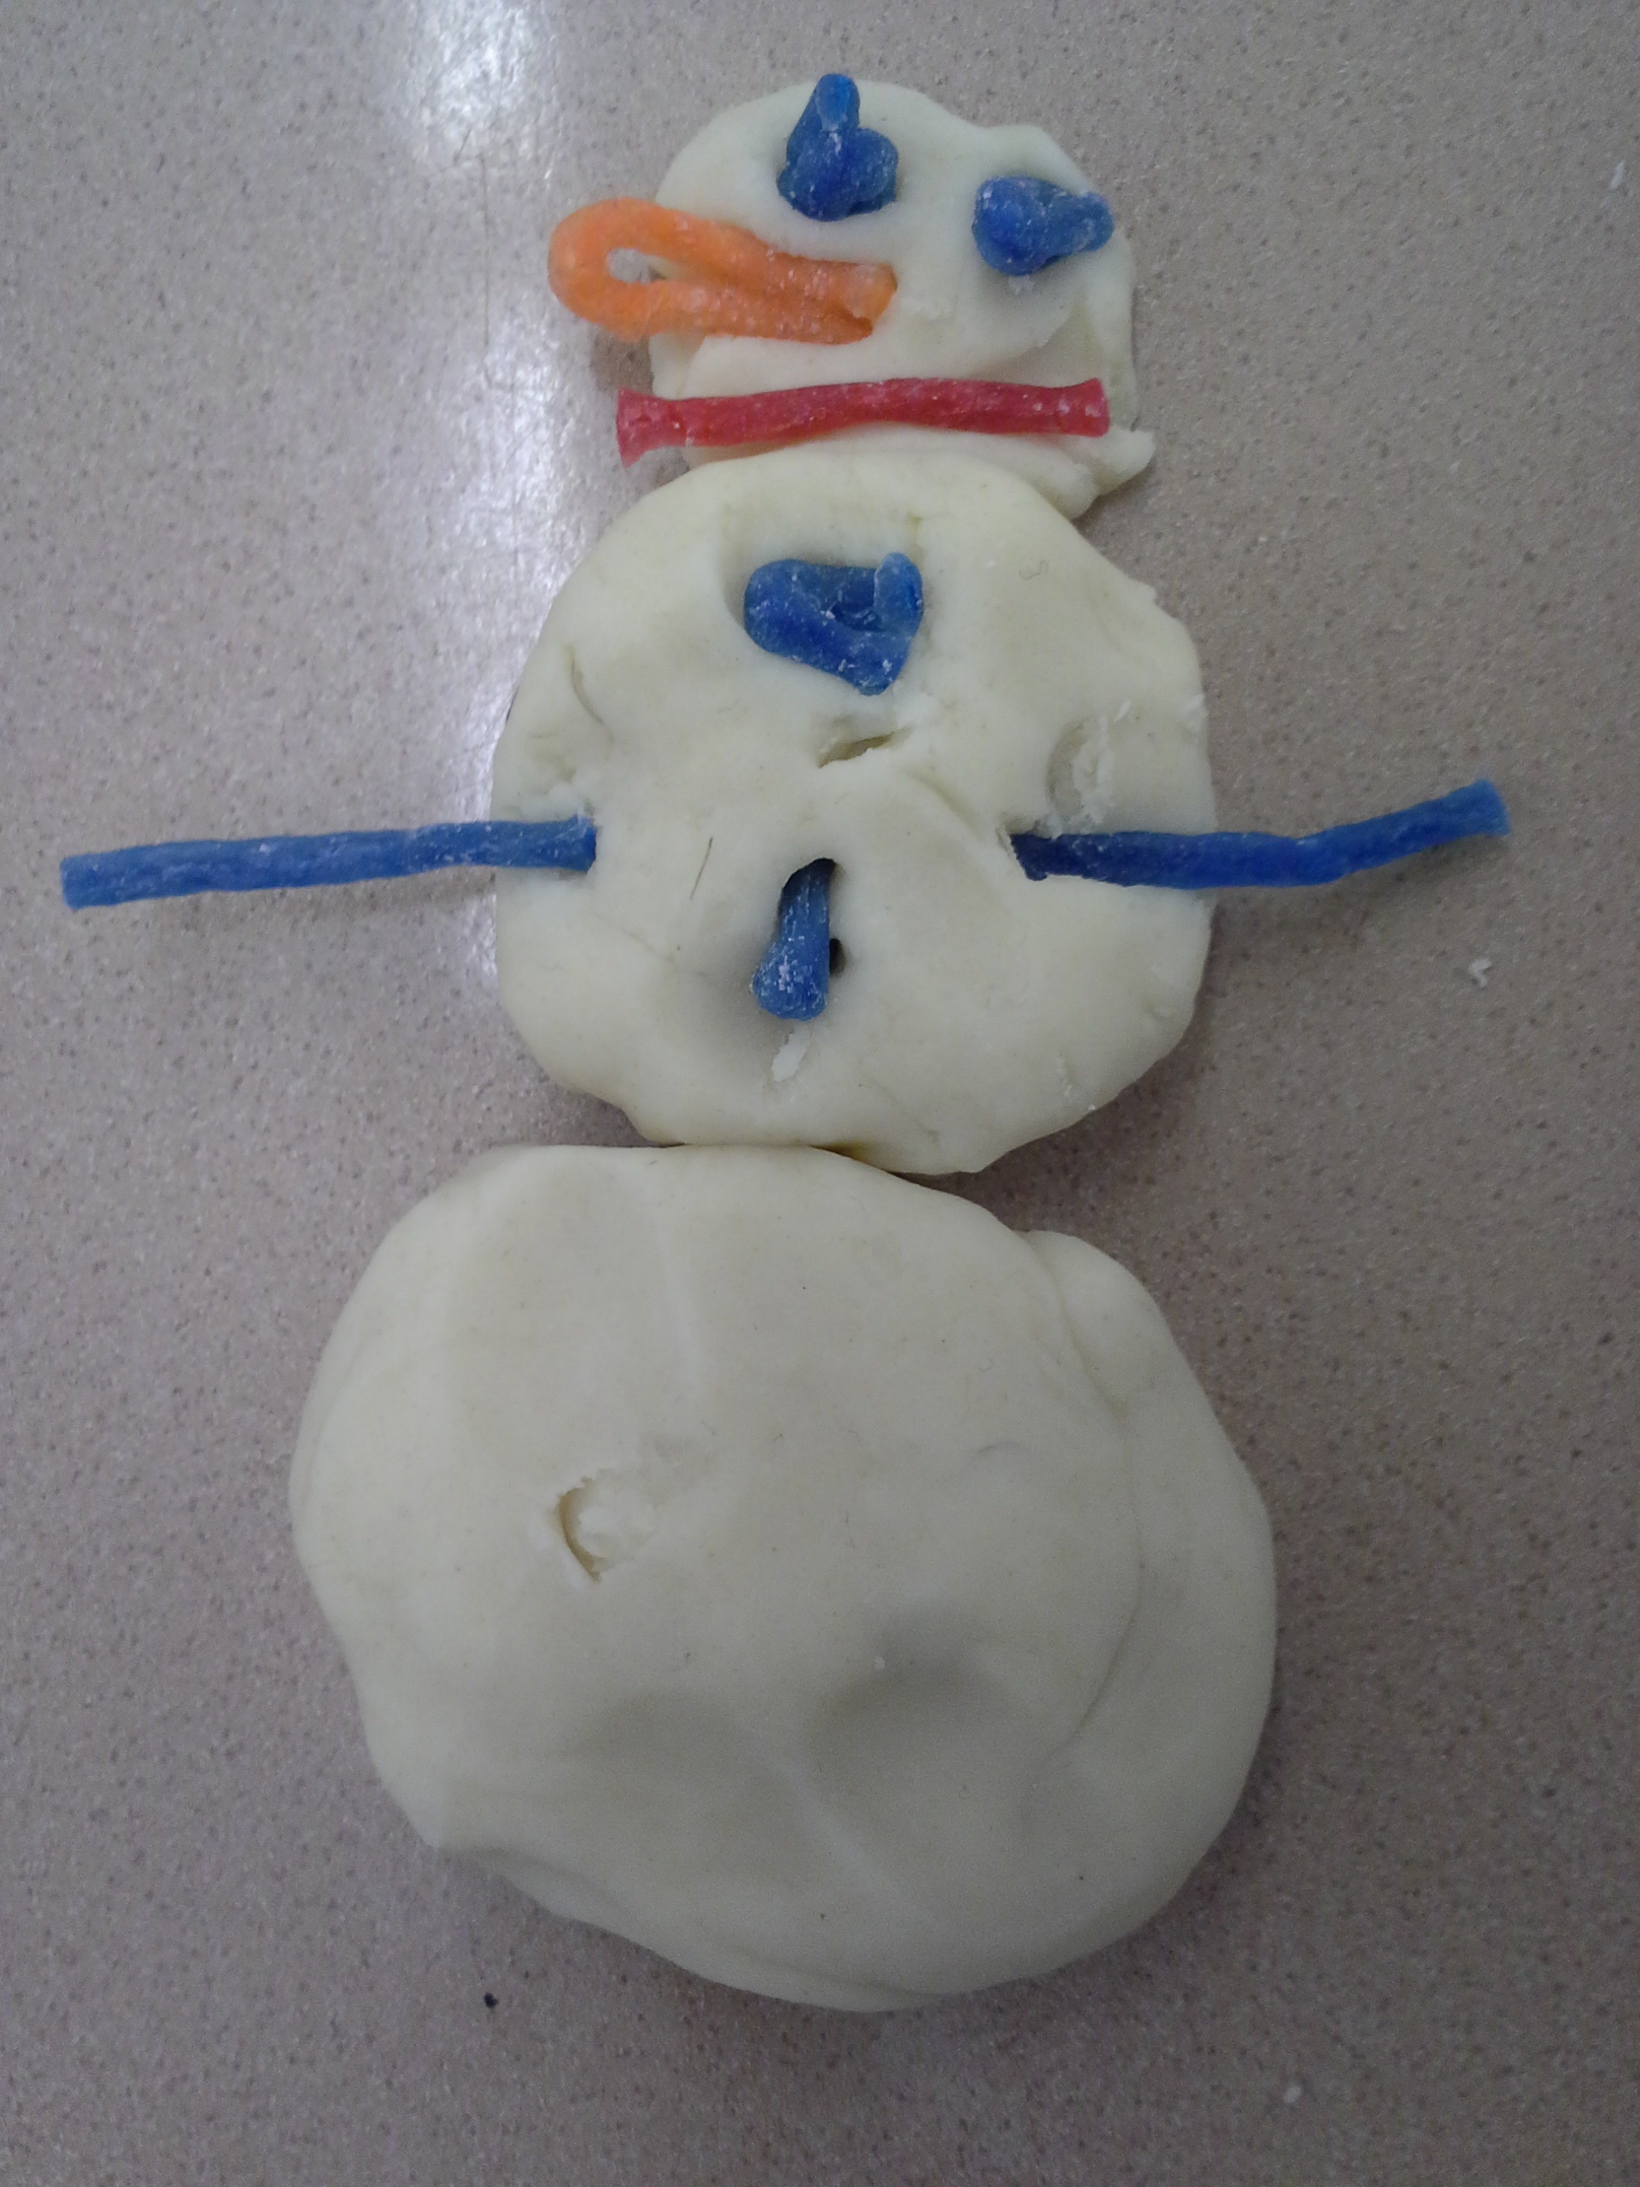
If you had been the teacher today, what would you have done differently?
What’s one nice thing you did for someone today?

Harris Elementary School/ 401-767-4855
Pragmatics is defined as the social use of language. While some students are able to speak and communicate clearly and correctly, they may still have difficulty with social language skills. They have difficulty learning the rules for social language. Difficulties in this area may be addressed by the Speech Language Pathologist or counselor in conjunction with the child’s classroom teacher. Pragmatic language involves three major communication skills:
1. Using language for different purposes, such as:
- Greeting
- Informing
- Requesting
2. Changing language according to the needs of a listener or situation, such as:
- Talking differently to a peer (e.g., out on the playground) than to a teacher in the classroom
- Giving background information to an unfamiliar listener
3. Following rules for conversation and story telling, such as:
- Taking turns to speak
- Staying on topic, or shifting topics as needed
- Standing the appropriate distance from someone during a conversation (not too close or too far)
Information from the American Speech-Language Hearing Association

Happy New Year!

“Social thinking is what we do when we interact with people: we think about them. And how we think about people affects how we behave, which in turn affects how others respond to us, which in turn affects our own emotions.” Michelle Garcia Winner developed a treatment framework and curriculum (Social Thinking) to address pragmatic language disorders. Find out more at: www.socialthinking.com
The ConversationBuilder™ (Pat. Pend.) App is designed to help children learn how to have multi-exchange conversations with their peers in a variety of social settings.

Communication

Internet Resources & Apps

Wish List

Harris Elementary School
60 High School Street

Phone:
401-767-4855

E-Mail:
mclarkmedyesy@woonsocketschools.com & KKrasuse@woonsocketschools.com
The following donations would be greatly appreciated:
- Small zip-lock bags
- Large zip-lock bags
- Clorox wipes
- Plastic spoons
- Plastic cups
- Tissues
- Liquid hand soap

Speech-Language Home Activity

Make a “puffy” winter scene! Talk with your child about what they might see or do out in the snow in order to get ideas for their painting. Discuss how to do different winter activities (e.g., What do you do to make a snowman? What could you use to decorate it? Where could we go sledding?).

Materials:
Shaving Cream
Elmer’s White Glue
Cardstock Paper

Instructions:
To make a batch of puffy paint, simply mix equal parts of shaving cream and Elmer's glue. Add food coloring, a few drops at a time, until you get the desired color. Apply the glue to heavy paper using a sponge brush. Let the painting dry.
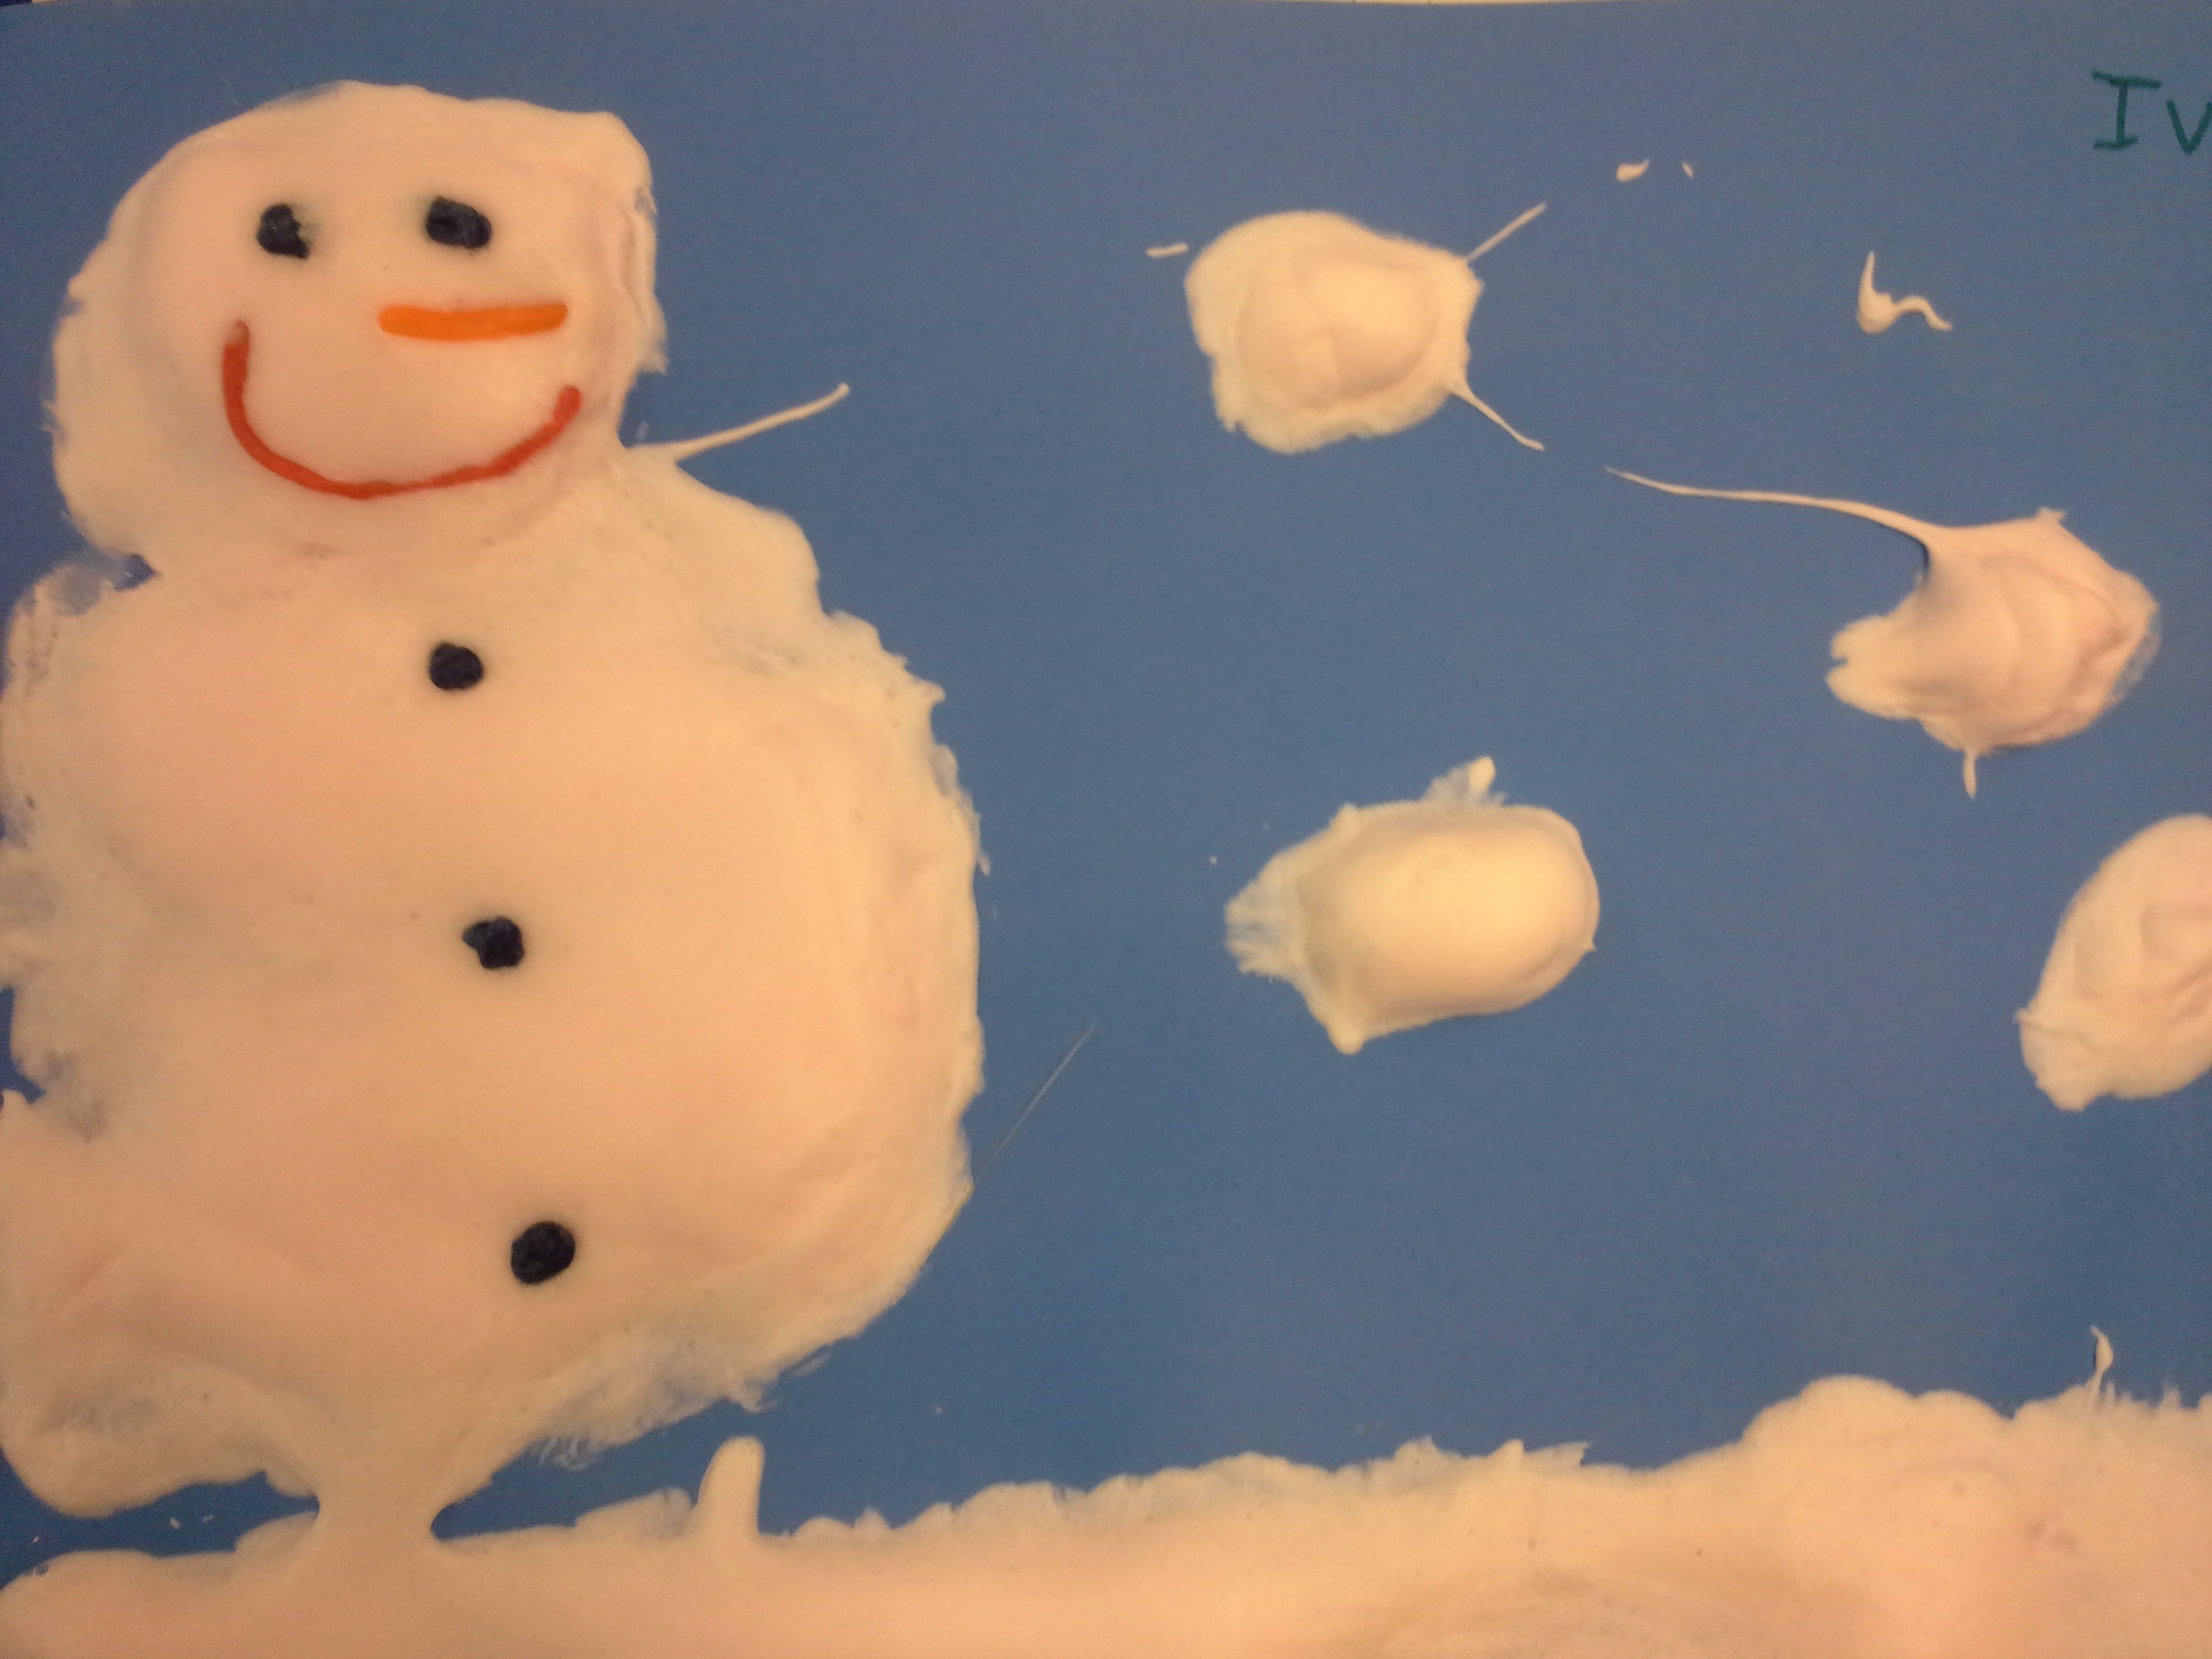

We’re on the Web!
See us at:
http://harrisspeechroom.weebly.com

