Problem Solving
The Speech Room
Harris Elementary School - Spring 2014 http://harrisspeechroom.weebly.com

The Super Hero Problem Solving Plan
• • •
When the problem begins…
Stop yourself &
take a deep breath!
Think about your
A) Positive
&
B) Negative Choices
Make a plan
&
Go With It!!!

So… How did it go?
Rewind and & Talk about it!

  - In Michelle Garcia Winner’s Social Thinking curriculum, (socialthinking.com) there is a villain named Glassman. Glassman causes people to overreact to small problems, as if they are shattering like glass. One way to defeat Glassman is to think about the size of the problem. You can help your child rate the problem on a scale of 1 to 10, and decide if what’s upsetting them is a small problem (like breaking a pencil point), medium problem, or big problem. After children have the proper perspective about the size of their problem, they are better able to match their reaction to it. For example, problems that are small and easy to solve, should not lead to crying and screaming.
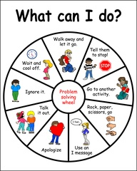

  - This problem-solving wheel is another strategy to help children find appropriate solutions.

Marilyn Toomey writes in her workbook, The Language of Perspective Taking, that “the ability to understand an event from another person’s point of view contributes to the development of the pragmatic aspect of language and communication”. Understanding thoughts and feelings helps us to develop social awareness.

Family Activity
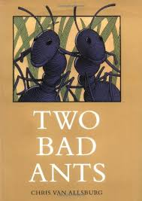
Read Two Bad Ants by Chris Van Allsburg. What a wonderful book for a perspective taking activity!
For more family pragmatic language activities visit www.lunchbuddiesplus.wordpress.com
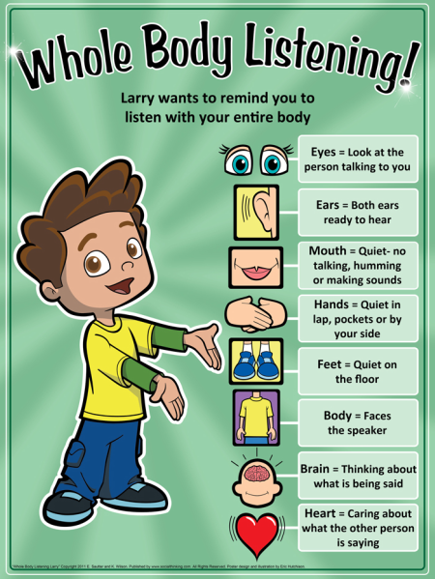

Summer Homework

  - A speech-language homework calendar will be sent home with the report card. Please have your student complete a daily 2 minute activity from the calendar to improve articulation, vocabulary, grammar and following directions. Those students who complete and return their summer homework will get a prize in September!
SUMMER READING
When reading with your child this summer, ask him/her questions about the story. Use a variety of “WH” and open-ended questions (e.g., “What do you think will happen next?” or “Where are they going?”). Ask your child to retell the story in the correct sequence (using the illustrations to help). Talk about the different characters and ask your child to describe the pictures. Have fun!

